About playing
juli 2019

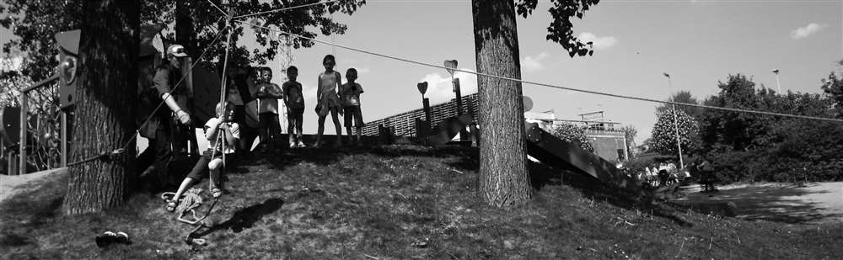
OUR VISION ON PLAYING
The Flemish Playground Service (in Dutch: VDS) has been a major player in Flemish youthwork for years because of its well-constructed vision on playing. For the VDS, “playing” is not the same as “playing at a playground”. For the latter, there is a concrete idea of how this “playing at a playground” should be organised, i.e. according to the principle of “playground work”. “Playing”, however, is a wider term and is, of course, not restricted to playgrounds.
Freedom as a main condition
Playing always happens in a person’s free time, a time in which they have fun. An important aspect of fun is in choosing how to fill in this time. There has to some degree of choice of activity. If the freedom of choice grows bigger, so will the chance on a child committing itself to fun completely. When someone tells you what to do, you can only comply or refuse, but there is little freedom of choice there. Because of this lack of freedom, there is no commitment and subsequently no fun in it. When there is freedom, a child will commit to the game completely and “blend” into it.
“PLAYING AND HAVING TO DO SOMETHING ARE TWO OPPOSITE THINGS. IF YOU HAVE TO PLAY, IS IT STILL PLAYING?”
Freedom in playing is not the same as freedom of choice. Playing is often an “open” term, in which a child can race with friends, create sandcastles and climb in trees. Playing can also be a “obligatory” game, as when the volunteer playworker proposes to play tag. In these cases, the child becomes an “actor” in its game. It has a function in the game and has an influence on what happens. This small degree of freedom within a “closed” game can be enough for a child to experience fun.
Intense playing as a goal
You can play to kill some time, you can play because you just feel the urge to, you can play to reach a goal, but you can also play because you completely committed to the game and “forgot” you were even playing at all. This kind of intense playing does not necessarily mean that you are extremely enthusiastic and energetic, but it does mean that the game is taking up all the free “space” inside the head of the child.
We talk about intense playing when there is commitment. If you are committed to playing, it’s as if only the game exists. Next to freedom as a basic condition, there are 3 more conditions.
- Interest
To reach full commitment, you need a healthy dose of interest in the game. Playing a woodland game in army theme will provoke disinterest in some children, even though the game itself might be well adapted to their age and level. On the other hand, making bracelets does not seem like a challenge, but some children will be find this interesting enough to not care about the lack of challenge. Their challenge is in making a beautiful bracelet with colourful combinations.
- Comfort
To let go completely at a playground, to completely immerse yourself in a game, you need to feel comfortable. This feeling is a combination of physical comfort (safety) and mental comfort (feeling secure within the group). The more you get comfortable, the less you get distracted by other factors and people outside the game. Comfort and challenge might seem like opposites, but they can co-exist quite well. A challenge will only be realistically possible when it’s within the child’s power to complete is. If it is too challenging, the child will not feel secure and will not participate.
An example: a rope course is challenging, but you are perfectly secured with buckles and ropes. The supervisors explain in detail what you have to do. Another example: a football match with 6 and 7 year olds against several teens is challenging for the little rascals because they have to face stronger opponents. Their group is bigger though, which gives them the comfort of number. For the teens, the opposite is true. The challenge is playing against a larger group and the comfort is the belief in their own strengths.
- Challenge
When you have found the right challenge, you often find yourself on the verge of your possibilities. Often you end up in a state called “flow”. That is the place where your capacities and your challenges meet each other. This state is very rewarding because you do something new, starting from a base you know and feel comfortable with. You can lose yourself in the game because of this. Your environment can get you into that state, but you yourself can get you there as well because of impulses you add to a game: new rules, other pieces of material, extra players, etc. A challenge doesn’t have to be “wow” or adventurous all the time. A small change to playing is often enough to give extra challenge.
Some examples: giving your Barbie dolls their first bath, kicking a ball into a tree, drawing the perfect apple, putting the handkerchief behind the animator, burying a shovel in the sand park, pranking someone, etc.
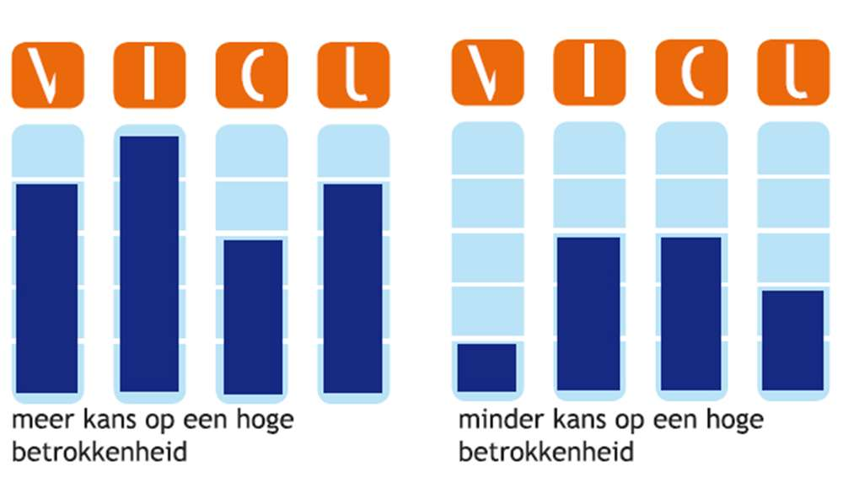
The VICU-metre
If these properties are more present, the higher the odds that the commitment level is higher which means the odds of intense playing are higher. To visualise that principle, the VICU-metre was developed in which the elements Freedom, Interest, Comfort and Challenge are visualised in four columns that show how strong each element is present.
The preference of children, is ours too
All recent researches show that when children are given the choice, they prefer an open form of playing. The open aspect of playing, spontaneous and unforced, offers the most chances of intense playing. This is the intense kind of fun they seek. When there is fun, the desire to keep playing is formed along with positive memories and a good feeling in general.

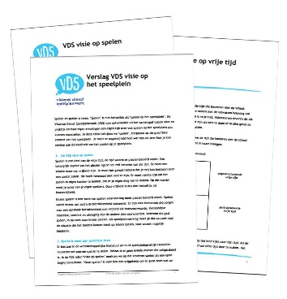
OUR VIEW ON PLAYING ON A PLAYGROUND
Our view on free time and view on playing form the base for our view on playing on the playground.
The starting point: variation and choice
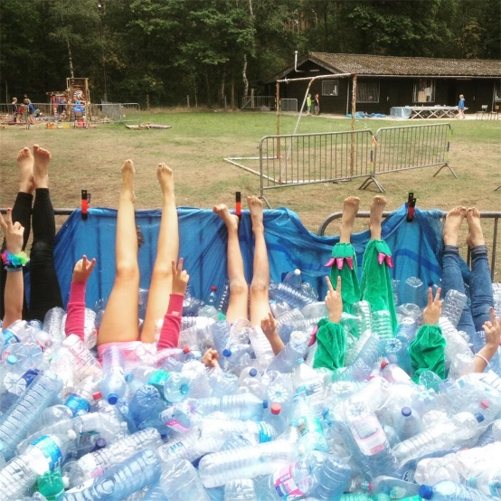
A holiday is not different for children than it is for adults. It is synonymous for “able to” and not “having to”. It is doing what you want to do. In that moment you experience a real holiday feeling. Playing is the main goal, intense playing the striving goal. Children have holidays, VDS aims at experiencing holidays! When playgrounds want their children to experience a real holiday feeling, variation and choice are necessary.
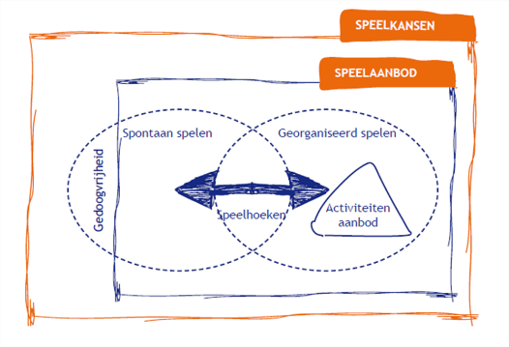
Every child is different. Some want to play with sand, other want to cook and there are those who want to dance. One child finds challenge in an adventurous course and another seeks the comfort of a self-made camp or comic books. This starting point determines the playground duty for us: creating a playing environment with as many playing chances and possibilities, giving every child the playing chances it wants. VDS strives to enlarge playing possibilities and use them better (scheme), making sure every child finds its “thing” at any time of day on the playground.
Playing “a la carte” in an open system to play
The playing system that, within a vacation context, offers the best playing possibilities in our view is a strong 'open system of playing'. The concept is based on choice and variation. The animators offer varied activities and children can play as much and as long as they want. They can switch activities and are stimulated through impulses and playing “corners”. Children make their own playing menu and enjoy a true holiday.
VDS believes playgrounds that do not have this system are not necessarily less qualitative. In reverse, playgrounds that have an open system aren’t necessarily qualitative either. Quality is context-bound. In practice, it’s about how playgrounds project their view on playing on their actual playground. It’s about how the children on they playground experience a holiday.
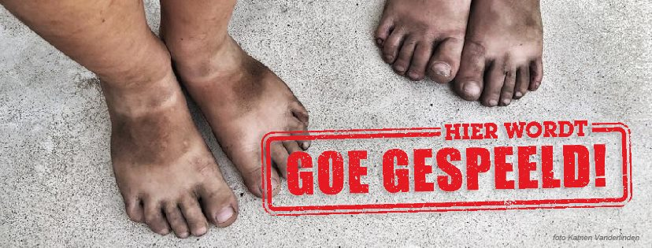
Well played!
On www.goegespeeld.be, you can find practical tips and background information on playing and playing themes.
Because we strive for more and better playing chances for each child, VDS launched “Goe Gespeeld!” in 2009 with several partners in youthwork. Goe Gespeeld! Is a plea for real playing en aims to create a positive playing environment in every community. Up to the present, VDS is the main drive in this project.
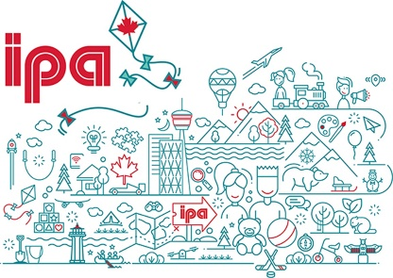
We defend the right to play
VDS does not defend this right in Flanders alone. In an international context, our organisation represents Belgium on the IPA (International Play Organisation). This union of almost 50 countries exists since 1961 and has as goal to defend and strengthen the right to play (as described in article 31 of the Children’s Rights Treaty) as a fundamental human right. In 2016, we joined the table in Istanbul and in 2017, we were welcomed in Canada.

